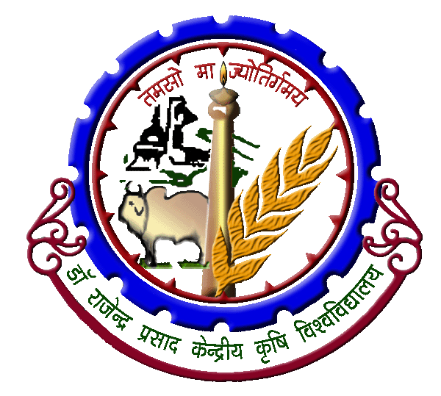 | Dr. Rajendra Prasad Central Agricultural University  Pusa (Samastipur) 848125 Bihar

APPLICATION FOR ISSUANCE OF NO OBJECTION CERTIFICATE FOR GETTING INDIAN PASSPORT/ VISA

Full Name (Capital letters) | :
Father’s Name | :
Designation | :
Date of joining in the University | :
Place of Posting | :
Name of wife/ husband (enclose her/his identity certificate) | :
Permanent Address | :
Present Address | :
Identity Card No. (enclose Xerox copy) | :
Mobile No. with email ID | :
Purpose for getting No Objection Certificate | :
Declaration of applicant | : | I am a citizen of India and have not been involved in any criminal case in India and that there is no criminal case pending against me in the Court of Law.
Encl: 03 passport size photo (in case of only passport)

Signature of applicant

Recommendation: above statements are checked and verified with the records available in the office and found correct for issuing No Objection Certificate.

Signature & seal of the
Head of Instt./ HOD

Order of the Registrar

